**ASSIGNMENT ANSWERS**

**Questions:**

1. Installation of VS Code:

- Describe the steps to download and install Visual Studio Code on Windows 11 operating system. Include any prerequisites that might be needed.

**Steps to Install Visual Studio Code on Windows**

**Step 1:** Visit the [**Official Website**](https://code.visualstudio.com/docs/?dv=win) of the **Visual Studio Code** using any web browser like [Google Chrome](https://www.geeksforgeeks.org/how-to-browse-in-google-chrome-browser/), [Microsoft Edge](https://www.geeksforgeeks.org/tools-and-features-in-microsoft-edge-browser/), etc.

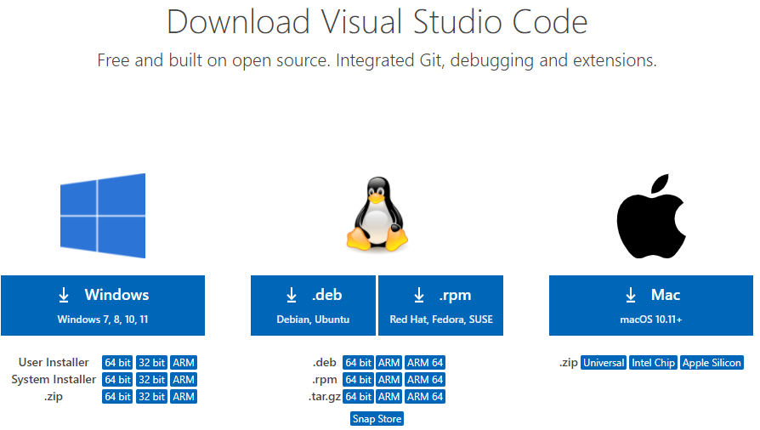

**Step 2:** Press the “**Download for Windows**” button on the website to start the download of the Visual Studio Code Application.



**Step 3:** When the download finishes, then the **Visual Studio Code Icon** appears in the downloads folder.

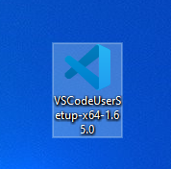

**Step 4:** Click on the **Installer** icon to start the installation process of the Visual Studio Code.

**Step 5:** After the Installer opens, it will ask you to accept the terms and conditions of the Visual Studio Code. Click on **I accept the agreement**and then clickthe **Next**button.

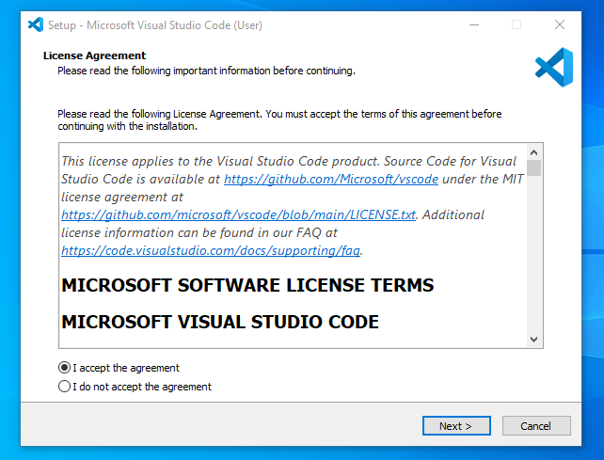

**Step 6:** Choose the location data for running the Visual Studio Code. It will then ask you to browse the location. Then click on the **Next** button.

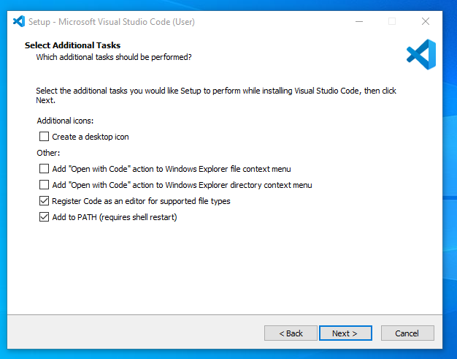

**Step 7:** Then it will ask to begin the installation setup. Click on the**Install** button.

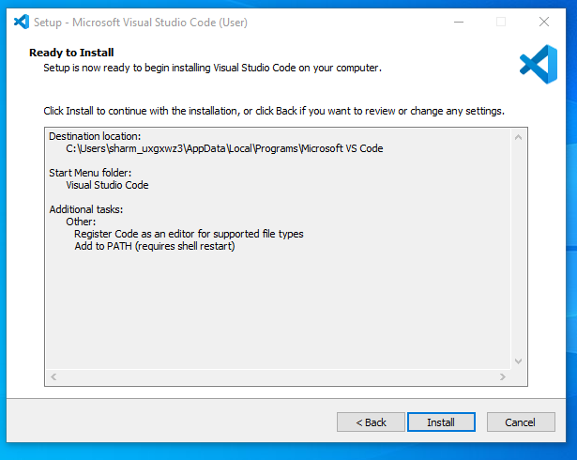

**Step 8:** After clicking on Install, it will take about 1 minute to install the Visual Studio Code on your device.

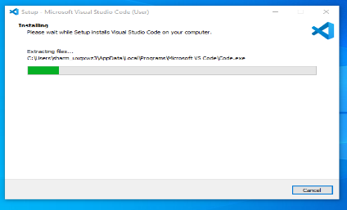

**Step 9:**After the Installation setup for Visual Studio Code is finished, it will show a window like this below. Tick the “**Launch Visual Studio Code**” checkbox and then click **Next**.

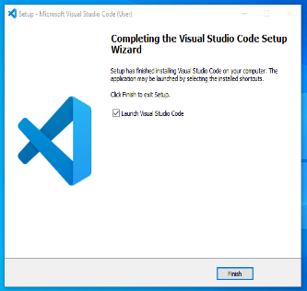

**Step 10:** After the previous step, the **Visual Studio Code window** opens successfully. Now you can create a new file in the Visual Studio Code window and choose a language of yours to begin your programming journey!

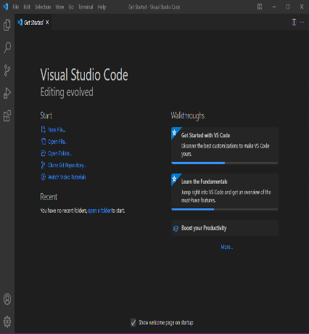

2. First-time Setup:

- After installing VS Code, what initial configurations and settings should be adjusted for an optimal coding environment? Mention any important settings or extensions.

***Theme:*** *VS Code offers a variety of themes for different preferences. You can explore them under "File" -> "Preferences" -> "Settings" (or "Code" -> "Preferences" -> "Settings" on macOS) and search for "Theme". Popular choices include Dark+ (default dark theme) and Light+ (default light theme).*

***Font Size and Line Height****: Adjust these under "Settings" -> "Editor" -> "Font Size" and "Editor" -> "Line Height" to suit your comfort level.*

***Auto Save****: Enable "Files: Auto Save" under "Settings" to ensure your work is saved automatically.*

***Keyboard Shortcuts:*** *VS Code offers extensive keyboard shortcuts for various actions. You can customize them under "Settings" -> "Keyboard Shortcuts".*

*Extensions*

***Code Formatting:*** *Use an extension like "Prettier - Code formatter" to automatically format your code according to a consistent style guide.*

***Linters and Static Code Analysis:*** *Consider extensions like "ESLint" or "Pylint" (depending on your language) to identify potential errors and code quality issues in your code.*

***Version Control:*** *If you'll be using Git for version control, install the built-in Git extension. This allows you to manage your code versions directly within VS Code.*

***Productivity Enhancements****: Several extensions can improve your coding workflow. Some popular options include:*

*"Live Server" for launching a development server with live reload.*

*"GitHub Copilot" (requires separate subscription) for AI-powered code suggestions.*

*"Bracket Pair Colorizer" for visually matching brackets and parentheses.*

3. User Interface Overview:

- Explain the main components of the VS Code user interface. Identify and describe the purpose of the Activity Bar, Side Bar, Editor Group, and Status Bar.

***1. Activity Bar (far left):***

* *Provides quick access to different views within VS Code.*
* *Icons represent various functionalities like:*
  + ***Explorer:*** *Manage your project files and folders.*
  + ***Search:*** *Search for files, symbols, or text across your project.*
  + ***Source Control (Git):*** *Interact with your Git repository (if enabled).*
  + ***Debug:*** *Launch and control the debugging process for your code.*
  + ***Extensions:*** *View and manage installed extensions.*
* *You can customize the order and visibility of icons in the Activity Bar through settings.*

***2. Side Bar (left of the editor):***

* *Hosts different views that provide additional context or functionality related to your code.*
* *The specific content displayed in the Side Bar depends on the currently active view from the Activity Bar.*
  + ***Explorer view:*** *Shows your project folders and files, allowing you to navigate and manage them.*
  + ***Search view:*** *Displays search results for files, symbols, or text within your project.*
  + ***Source Control view:*** *Provides information and actions related to your Git repository.*
  + ***Debug view:*** *Offers controls for debugging your code during execution.*
* *You can collapse or expand the Side Bar to manage screen space.*

***3. Editor Group (centre area):***

* *The heart of VS Code, where you write, edit, and view your code.*
* *You can open multiple files simultaneously and arrange them in tabs within the Editor Group.*
* *Each tab represents a single file you're working on.*

***4. Status Bar (bottom of the window):***

* *Displays contextual information about your current workspace and project.*
* *It typically shows details like:*
  + *The current line number and character position within the active file.*
  + *Information about your Git repository status (if enabled).*
  + *Language mode of the active file.*
  + *Active indentation settings.*
* *The Status Bar can also display custom messages or warnings from extensions.*

4. Command Palette:

- What is the Command Palette in VS Code, and how can it be accessed? Provide examples of common tasks that can be performed using the Command Palette.

*The Command Palette in VS Code is a tool that acts as a centralized hub for searching and executing various actions and commands within the IDE. It allows you to quickly access functionalities without needing to navigate through menus or memorize keyboard shortcuts.*

***Accessing the Command Palette:***

*There are three ways to access the Command Palette:*

1. ***Keyboard Shortcut:*** *The most common way is to use the keyboard shortcut:*
   * ***Windows/Linux:*** *Ctrl+Shift+P*
2. ***Go To Menu:*** *Click on the "Go To" menu option in the top menu bar and select "Command Palette".*

***Examples of Common Tasks:***

*Here are some examples of common tasks you can perform using the Command Palette:*

* ***Open a File:*** *Type the name of the file you want to open and select it from the list.*
* ***Search for Symbols:*** *Search for functions, variables, or other symbols within your project.*
* ***Navigate to a Line:*** *Specify the line number you want to jump to within the active file.*
* ***Refactor Code:*** *Access options for renaming symbols, extracting functions, or other code refactoring operations.*
* ***Run a Task:*** *Execute build tasks, tests, or other custom scripts defined in your project.*
* ***Install Extensions:*** *Search for and install extensions to add new functionalities to VS Code.*
* ***Change Settings:*** *Access and modify various settings for the VS Code editor itself.*

5. Extensions in VS Code:

- Discuss the role of extensions in VS Code. How can users find, install, and manage extensions? Provide examples of essential extensions for web development.

*VS Code extensions are like plugins that significantly extend its functionalities and cater to specific development needs. They allow you to customize your development environment and add powerful features tailored to various programming languages, frameworks, and development tasks.*

***Finding, Installing, and Managing Extensions:***

*There are three primary ways to find, install, and manage extensions:*

1. ***VS Code Marketplace:*** *This is the built-in extension marketplace within VS Code. You can access it by clicking on the Extensions icon (puzzle piece icon) in the Activity Bar. Here you can browse extensions by category, popularity, or search for specific functionalities.*
2. ***Search Online:*** *Many developers share and recommend extensions online. You can search for "VS Code extensions for [your development area]" to find relevant options.*
3. ***Command Palette:*** *Open the Command Palette (Ctrl+Shift+P) and type "Extensions: Install Extension". This will allow you to search for extensions directly within VS Code.*

*Once you find an interesting extension, you can click the "Install" button to add it to your VS Code environment. Installed extensions are listed in the Extensions view and can be disabled, uninstalled, or updated from there.*

***Essential Extensions for Web Development:***

*Here are some examples of essential extensions for web development that can enhance your workflow:*

* ***Essential Language Extensions:***
  + ***JavaScript (by ESLint):*** *Includes linting, code formatting, and debugging support for JavaScript and related technologies like TypeScript or React.*
* ***Linters and Static Code Analysis:***
  + ***Stylelint:*** *Enforces consistent code style and formatting for CSS and related languages.*
* ***Task Runners and Build Tools:***
  + ***Grunt or Gulp:*** *These extensions allow you to automate tasks like building, testing, and minifying your web project.*
* ***Version Control:***
  + ***Git (built-in):*** *Provides seamless integration with Git for version control and collaboration.*
* ***Live Server:*** *Launches a development server with live reload functionality, allowing you to see changes reflected in your browser instantly while coding.*
* ***Debuggers:***
  + ***Debugger for Chrome (by Microsoft):*** *Enables debugging of your web applications directly within Chrome browser from VS Code.*

**6. Integrated Terminal:**

**- Describe how to open and use the integrated terminal in VS Code. What are the advantages of using the integrated terminal compared to an external terminal?**

***Opening the Integrated Terminal:***

*There are three ways to open the integrated terminal in VS Code:*

1. ***Menu Bar:*** *Click on the "Terminal" option in the menu bar and select "New Terminal".*
2. ***Keyboard Shortcut:*** *The most convenient way is to use the keyboard shortcut:*
   * ***Windows/Linux:*** *Ctrl+ (backtick)*

*Once you open the terminal, you'll see a new panel at the bottom of the VS Code window. This panel functions as a standard terminal window where you can type your command line commands.*

***Advantages of Using the Integrated Terminal:***

*Using the integrated terminal within VS Code offers several advantages over using a separate terminal window:*

* ***Convenience:*** *It's readily accessible within your development environment, eliminating the need to switch windows or applications.*
* ***Improved Workflow:*** *You can quickly execute commands related to your project without leaving your code editor.*
* ***Context Awareness:*** *The integrated terminal can sometimes be context-aware of your current project and working directory. This can streamline workflows for tasks like running project-specific scripts.*
* ***Integration with VS Code Features:*** *Some VS Code features, like tasks or debugging, might directly interact with the integrated terminal, providing a seamless experience.*
* ***Split View:*** *You can split the VS Code window to see both your code and the terminal side-by-side, allowing you to easily reference your code while working in the terminal.*

**7. File and Folder Management:**

**- Explain how to create, open, and manage files and folders in VS Code. How can users navigate between different files and directories efficiently?**

***Managing Files and Folders in VS Code: Keeping Your Project Organized***

*VS Code offers intuitive functionalities for creating, opening, and managing files and folders within your project. Here's a breakdown of the essential methods:*

***Creating Files and Folders:***

1. ***Explorer View:*** *Open the Explorer view by clicking on the files icon (folder icon) in the Activity Bar. This view displays your project folders and files.*
2. ***Right-Click Menu:*** *Right-click within the Explorer view to create a new file or folder:*
   * *Select "New File" to create a new blank file.*
   * *Choose "New Folder" to create a new folder.*

***Opening Files:***

1. ***Explorer View:*** *Double-click on a file name in the Explorer view to open it in the editor area.*
2. ***Go to File:*** *Use the "Go to File" functionality for quick access:*
   * *Open the Command Palette (Ctrl+Shift+P) and type "Go to File".*
   * *Start typing the name of the file you want to open, and VS Code will suggest matching files.*
   * *Select the desired file to open it in the editor.*

***Managing Files and Folders:***

1. ***Renaming:*** *Right-click on a file or folder and select "Rename" to change its name.*
2. ***Moving and Deleting:*** *Right-click on a file or folder and choose "Cut" or "Copy" to move or copy it within your project. You can then right-click in the destination folder and select "Paste". Alternatively, use the keyboard shortcuts Ctrl+X (cut), Ctrl+C (copy), and Ctrl+V (paste). You can also right-click and select "Delete" to remove a file or folder (be cautious!).*
3. ***Drag and Drop:*** *Drag and drop files or folders within the Explorer view to move or copy them.*

***Navigating Efficiently:***

* ***Explorer View:*** *Use the Explorer view to browse your project directory structure and quickly access different files and folders.*
* ***Go to Symbol:*** *Use the "Go to Symbol" functionality (Ctrl+T) to jump to specific functions, variables, or other symbols within your project files.*
* ***Recent Files:*** *VS Code maintains a list of recently opened files. Access this list by clicking on the "Go To" menu option in the top menu bar and selecting "Recent Files".*

**8. Settings and Preferences:**

**- Where can users find and customize settings in VS Code? Provide examples of how to change the theme, font size, and keybindings.**

**Finding and Customizing Settings:**

1. ***Settings Editor:***
   * *Open the Command Palette (Ctrl+Shift+P) and type "Settings" or "Preferences" (depending on your operating system).*
   * *Select "Preferences: Open Settings" from the list.*
   * *This opens the Settings Editor, a searchable interface displaying all available settings.*

***Changing the Theme:***

* *In the Settings Editor, search for "Theme".*
* *A dropdown menu will display available themes. Choose a theme you prefer (e.g., Dark+, Light+).*
* *The preview window will show you how the theme affects the editor's appearance.*
* *Select the theme you like, and it will be applied immediately.*

***Adjusting Font Size:***

* *Search for "Font Size" in the Settings Editor.*
* *A slider or input field allows you to adjust the font size to your desired level.*
* *Preview the changes in the editor window as you adjust the slider.*
* *Once you find a comfortable font size, confirm the change.*

***Modifying Keybindings:***

* *Search for "Keyboard Shortcuts" in the Settings Editor.*
* *This opens a list of all default keyboard shortcuts.*
* *You can search for specific actions or browse through the categories.*
* *To change a keybinding, click on the existing shortcut next to the desired action.*
* *Press the new key combination you want to use for that action.*
* *VS Code will highlight any conflicts with existing shortcuts. Resolve conflicts if necessary.*
* *Save your changes, and the new keybinding will be applied.*

***Additional Customization:***

*The Settings Editor allows you to customize various other aspects of VS Code, such as:*

* *Editor behaviour (auto-save, indentation, etc.)*
* *Integrated terminal settings*
* *Language-specific settings (e.g., syntax highlighting)*
* *Extensions settings (if applicable)*

**9. Debugging in VS Code:**

**- Outline the steps to set up and start debugging a simple program in VS Code. What are some key debugging features available in VS Code?**

***1. Prerequisites:***

* *Ensure you have the necessary development environment set up for your programming language (e.g., Node.js for JavaScript).*
* *Have a basic understanding of debugging concepts like breakpoints and step execution.*

***2. Create a Launch Configuration (Optional):***

* *Launch configurations define how VS Code launches and debugs your program.*
* *While not strictly necessary for simple programs, they become useful for managing complex debugging scenarios.*
* *To create a launch configuration:*
  + *Go to the "Run and Debug" view (usually on the left sidebar).*
  + *Click on the "+" icon and select "Launch Configuration".*
  + *Choose a template or create a custom configuration based on your programming language and environment.*

***3. Set Breakpoints:***

* *Breakpoints are points in your code where execution pauses, allowing you to inspect variables and the program's state.*
* *Click on the line number next to the line of code where you want to pause execution.*
* *A red dot appears, indicating a breakpoint.*

***4. Start Debugging:***

* + *Click on the green play button (with a bug icon) in the "Run and Debug" view.*

***5. Debugging Features:***

*Once your program is paused at a breakpoint, VS Code offers several debugging features:*

* ***Step Over (F10):*** *Executes the current line of code and pauses at the next line.*
* ***Step Into (F11):*** *Steps into function calls, pausing at the first line of the called function.*
* ***Step Out (Shift+F11):*** *Steps out of the current function, pausing at the line after the function call.*
* ***Continue (F5):*** *Resumes program execution until the next breakpoint or program termination.*
* ***Debug Console:*** *View variable values, expressions, and program output.*
* ***Call Stack:*** *See the sequence of function calls leading to the current execution point.*
* ***Variables:*** *Inspect the values of variables at the current breakpoint.*

***6. Stop Debugging:***

* *Once you've finished debugging, click on the red square button (stop button) in the "Run and Debug" view.*

**10. Using Source Control:**

**- How can users integrate Git with VS Code for version control? Describe the process of initializing a repository, making commits, and pushing changes to GitHub.**

**1. Prerequisites:**

* Ensure you have Git installed on your system. You can download and install it from <https://git-scm.com/>.
* Create a free GitHub account at <https://github.com/Index> if you plan to host your code there.

**2. Initializing a Git Repository:**

* Open your project folder in VS Code.
* Go to the "Source Control" view (usually on the left sidebar). If you don't see it, click on the "+" icon and select "Source Control".
* The view might display "No Git repository found". Click on the "(...)" button and select "Initialize Repository". This creates a new Git repository within your project folder.

**3. Making Commits:**

* After making changes to your code, stage those changes for your next commit.
* Staged changes are files you want to include in your next commit snapshot.
* In the "Source Control" view, you'll see a list of modified files.
* Click on the "+" icon next to a file to stage it. Alternatively, right-click on the file and choose "Stage Changes".
* Once you've staged your desired changes, click on the blue "Commit" button in the Source Control view.
* Enter a descriptive commit message that summarizes the changes you made.
* Click on the checkbox next to "Stage Changes" (optional) to automatically stage all modified files for the next commit.
* Click on the green checkmark button to commit your staged changes.

**4. Pushing Changes to GitHub (Optional):**

* Once you have committed your changes, you can push them to a remote repository like GitHub.
* In the "Source Control" view, click on the "..." button next to the main branch name (usually "master").
* Select "Publish branch" and choose your desired remote repository (e.g., your GitHub repository).
* If it's your first time connecting, you might need to authenticate with your GitHub credentials.
* VS Code will guide you through the process of creating a new remote repository on GitHub or linking to an existing one.
* Once the connection is established, click on "Push branch" to send your committed changes to the remote repository on GitHub.

**REFERENCES**

Absolutely, here are the references for the content provided above:

**1. Installation of VS Code:**

* Visual Studio Code documentation: <https://code.visualstudio.com/download>

**2. First-time Setup:**

* Visual Studio Code documentation - Settings: <https://code.visualstudio.com/docs/getstarted/settings>
* Visual Studio Code Marketplace: <https://code.visualstudio.com/docs/editor/extension-marketplace>

**3. User Interface Overview:**

* Visual Studio Code documentation - Interface: <https://code.visualstudio.com/api/ux-guidelines/status-bar>

**4. Command Palette:**

* Visual Studio Code documentation - Keyboard shortcuts: <https://code.visualstudio.com/docs/getstarted/keybindings>

**5. Extensions in VS Code:**

* Visual Studio Code Marketplace: <https://code.visualstudio.com/docs/editor/extension-marketplace>

**6. Integrated Terminal:**

* Visual Studio Code documentation - Integrated Terminal: <https://code.visualstudio.com/docs/terminal/basics>

**7. File and Folder Management:**

* Visual Studio Code documentation - Working with Files: <https://m.youtube.com/watch?v=Gkhs1EJRRxg>

**8. Settings and Preferences:**

* Visual Studio Code documentation - Settings: <https://code.visualstudio.com/docs/getstarted/settings>

**9. Debugging in VS Code:**

* Visual Studio Code documentation - Debugging: <https://code.visualstudio.com/docs/editor/debugging>

**10. Using Source Control:**

* Visual Studio Code documentation - Git: <https://code.visualstudio.com/docs/introvideos/versioncontrol>
* Git SCM - Download Git: <https://git-scm.com/downloads>
* GitHub: <https://github.com/Index>